2024
Military

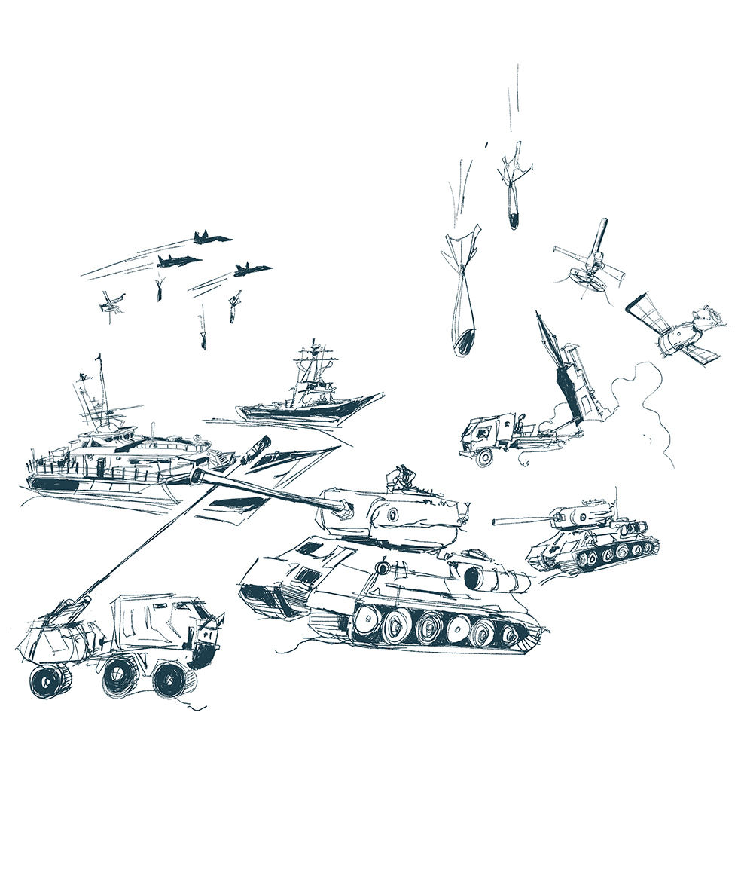

by Howgate www.howgatepublishing.com

Do you have a book idea?

We are always on the search for new projects to develop. We would like to hear from you if you are finding that the current literature available is no longer relevant or falls short of your requirements. We can’t promise to produce a book from every request, but we will certainly consider your suggestions carefully for our forward publishing programme.

If you have an idea that you are keen to develop yourself, please contact our publisher, Kirstin Howgate, at: kirstin@howgatepublishing.com

Details of how to submit a book proposal can be found at:
howgatepublishing.com/bookproposal

Inspection Copy Policy and Request

Inspection or examination copies are available to teaching staff who wish to evaluate a book’s suitability for adoption as a course text recommendation for student purchase.

Please see our website for further details at: howgatepublishing.com/inspectioncopy

Request a review copy

To request a review copy, please contact us at: info@howgatepublishing.com

Follow us on:

Rewards for subscribers

Mailing list members receive the following benefits:

- This is where we will post links to chapters of our books where only members can read for free

- We have been known to write widely read and useful blogs which we will share here

- Of course we also want you to use and encourage others to use our books so it's the place to receive early bird notice of new books

- You will be the first to know about new events some of which we co-host and/or exhibit at

- Plus the first to know about calls for new project contributions

- Reviews of our books will appear here

- The occasional external post may be shared if relevant to our interests

- You will be part of a growing and influential PME community

- This will be where you find out about special offers

- There's nothing for you to do other than enjoy the benefits.

To subscribe, please go to the website at
howgatepublishing.com

Author benefits

As a Howgate author you are entitled to a 30% discount on all of our print books. Also, if you decide to adopt one of our books, the price for this copy will be refunded.

Contents

Military Virtues
Cyber Warfare Ethics
Military Space Ethics
Issues in Military Ethics series
Military Justice Handbook
Mission Improbable: The Transformation of the British Army Reserves
War Amongst the People: Critical Assessments
Fragile and Failing States: Challenges and Responses
Violent Non-State Actors in Modern Conflict
Sandhurst Trends in International Conflict series
Air Forces: The Next Generation
Something Rotten: Land Command in the 21st Century
Understanding Urban Warfare
Women, Peace and Security in Military Operations
War’s Changed Landscape
Information Operations: Facts Fakes Conspiracists
The Western Way of War
War and Warfare in the 20th Century
War Without Oversight
Conflict Realism

Index
Distribution

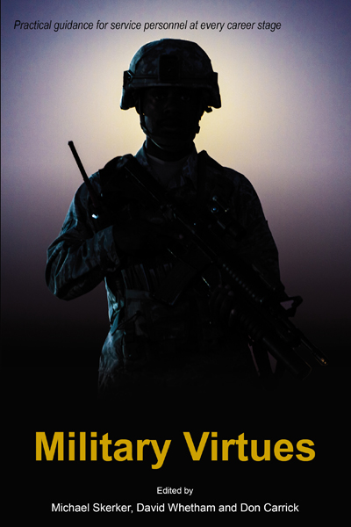
Military Virtues
Edited by Michael Skerker, US Naval Academy, David Whetham, King’s College London at the Joint Services Command and Staff College and Don Carrick

…Anyone who cares about the ethos of our unique Armed Services will read this pioneering book with interest and profit.
Professor John Adair, Chair of Leadership, United Nations
…review carefully the corresponding case studies of each [virtue] and then strive to master not just one, not just two, but all 14.
Captain Mike Michel, Deputy Commandant for Leadership & Character Development, USNA
…skilfully balances examination of the conceptual understanding of these virtues with extremely helpful case studies which make the conceptual analysis concrete and clear.
Professor Martin Cook, Admiral Stockdale Professor of
Professional Military Ethics, USNWC
…Hugely readable, fascinating and adept at drawing on both the successes and mistakes of our predecessors, it is a ‘must read’ for anyone involved in leadership in the military or commercial sector, from those at the ‘coal face’ to the board room.
Brigadier WSC Wright OBE, Commander Sandhurst Group
…valuable guidance or reflection for military commanders at any level, and a valuable resource for academic study
Journal of Military Ethics
…a treasure trove of real-world international cases of military moral dilemmas – and at time, outright moral failures – of enviable breadth and depth
Strategy Bridge
…anyone interested in ethics is interested in examples of the application of ethical thinking, and here we have exactly that. The Wavell Room

Contents
List of Figures. Notes on Contributors. Preface. Intro: Military Values and Moral Relativism Prof Peter Olsthoorn; Virtues or Values Rev. Prof Philip McCormack MBE. 1. Justice: Overview Dr Edward T. Barrett (Col USAF ret); Case Study 1: Doing a Deal with the Devil? Just Cause, David Richards and the Case of Op PALLISER Lt. Col. Thomas McDermott DSO (Australian Army); Case Study 2: Gender Equality as Fairness in the Military Institution Lt. Col. Kate Germano (USMC ret) and Dr David G. Smith. 2 Obedience: Overview Prof Jessica Wolfendale; Case Study 1: Strategic Dissent in the Military Ambassador Reuben E. Brigety and Prof Shannon E. French; Case Study 2: Should Service Personnel Refuse to Fight in Unjust Wars? Prof David Whetham. 3 Loyalty: Overview Prof David Whetham; Case Study 1: Levels of Loyalty: Country, Service, Mission, Troops Rev. Prof Philip McCormack MBE; Case Study 2: Good Loyalty and Bad Loyalty Dr Stephen Coleman. 4 Courage: Overview Dr Pauline Shanks Kaurin; Case Study 1: Courage in the Age of Technology Dr Peter Lee; Case Study 2: Moral Courage Lt. Col. Scott Cooper (USMC ret). 5 Wisdom: Overview Capt Rick Rubel (USN ret.); Case Study 1: Wisdom and Judgement Capt Rick Rubel (USN ret); Case Study 2: Operational Wisdom: Aggressive Restraint in the Global War on Terror Col. Steven M. Kleinman (USAF ret.).6 Honesty: Overview Col. James L. Cook; Case Study 1: Honesty and Deceit in War Mr Ian Fishback (US Army ret); Case Study 2: Cannibals, Gun-Deckers and Good Idea Fairies: Structural Incentives to Deceive in the Military Prof Michael Skerker. 7 Integrity: Overview Mr Don Carrick; Case Study 1: Integrity, Institutions and the Banality of Complicity Dr Michael Robillard (Airborne Ranger ret); Case Study 2: Getting Away with Murder? The Limits of Integrity Mr Don Carrick. 8 Perseverance: Overview RADM Alan T. Baker (USN ret); Case Study 1: Perseverance, Leadership, and the ‘We’ Dr Michael Robillard (Airborne Ranger ret); Case Study 2: Thinking Beyond the Past: Nudging the Pentagon Toward the 21st Century Col. Steven M. Kleinman (USAF ret). 9 Temperance: Overview Dr Stephen Deakin; Case Study 1: Temperance in Practice LCdr. Michael D. Good; Case Study 2: Unit Temperance and the Haditha Case Col. David M. Barnes (US Army). 10 Patience: Overview CDR Michael A. Flynn USN; Case Study 1: Patience Chaplain Rev. Dr Nikki Coleman RAAF; Case Study 2: Patience with Subordinates Col. James L. Cook. 11 Humility: Overview Prof Michael Skerker; Case Study 1: On Humility Capt Rick Rubel (USN ret); Case Study 2: Humility: Lessons from the Context of Interrogation Mr Erik Phillips. 12 Compassion: Overview Rev. Prof Philip McCormack MBE; Case Study 1: Compassion toward Enemies Lt. Gen. John F. Sattler (USMC ret) and Prof Michael Skerker; Case Study 2: Compassion Lt. Col. Rafford M. Coleman. 13 Discipline: Overview Prof Paul Robinson; Case Study 1: The Necessity of Self Control and the Perils of Anger Brig Gen. Benoit Royal (ret); Case Study 2: Discipline of Violence SOC Daniel Luna and LTJG Max Goldwasser. 14 Professionalism: Overview Dr Daniel Lagacé-Roy and Dr Carl Jacob; Case Study: Professionalism Air Cdre. John Thomas (RAF ret). Conclusion: AVM Johnny J. Stringer CBE RAF.

Why should I read it?
This book is unique in the just war/military ethics literature in that it brings together academics and service personnel to address the topic of military virtue in a format that is accessible and relevant to military professionals. Open personal experiences of ethical decisionmaking help to highlight the complexities of acting ethically within the military system. Authors are leading scholars in the field of just war theory and military personnel range from a special operations chief to a three star general.

Publication date: 1st May 2019
Paperback 9781912440009 / Kindle 9781912440016 / EPUB 9781912440108
Price: £29.99 / US$39.99 / €36.99 / Aus$59.99
Extent: 410 pages / Size: 234 x 156mm /Thickness: 21.31mm / Weight: 1.264 lb
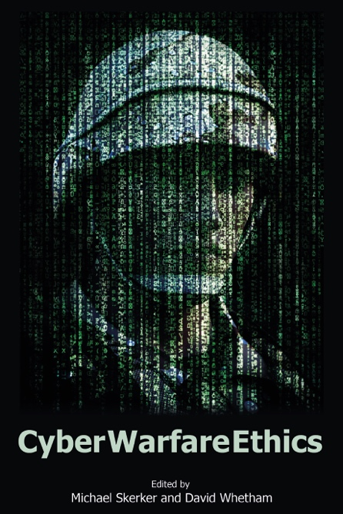
Cyber Warfare Ethics
Edited by Michael Skerker, US Naval Academy and David Whetham, King’s College London at the Joint Services Command and Staff College

An accurate and comprehensive collection that captures the various ethical and moral challenges that we as cyber warfare planners and operators grapple with continuously, illustrated through both real world and notional case studies. Cyber Warfare Ethics addresses these concerns across a wide range of cyber warfare operations as well as those inherent in the use of today’s advanced technology employed in warfare. Anyone interested in cyber warfare should read this book to understand the important ethical considerations of this rapidly evolving, critical warfare area.
Captain James Caroland, Chair, Cyber Science Department, U.S. Naval Academy and U.S. Navy Cyber Warfare Engineer

Cyber operations, both above and below the threshold of violent conflict, continue to vex policy makers and strategists. With thousands of years of experience in physical conflict, nations are still developing their operational, legal and ethical approaches to this newer non-kinetic realm. Concepts such a proportionality and discrimination must be taken into account in these evolving national security architectures. This new book provides a range of very useful insights for national security leaders and their organisations as they traverse the challenges of developing, absorbing, employing and evolving new age cyber capabilities. Cyber Warfare Ethics is a publication that should be on the reading list for anyone – policy makers, strategists, academics and citizens - with an interest in the ethical application of all forms of cyber power in the coming decades.
Major General Mick Ryan, Commander Australian Defence College

About the Book
Cyber technology gives states the ability to accomplish effects that once required kinetic action. These effects can now be achieved with cyber means in a manner that is covert, deniable, cheap, and technologically feasible for many governments. In some cases, cyber means are morally preferable to conventional military operations, but in other cases, cyber’s unique qualities can lead to greater mischief than governments would have chanced using kinetic means. This volume addresses the applicability of traditional military ethics to cyber operations, jus ad vim (an emerging sub-field governing grey zone or soft war operations), the rights of the targets of cyber operations, cyber sabotage, cyber surveillance, phase zero operations, psychological operations, artificial intelligence, and algorithmic ethics. Uniquely, it includes a number of cyber incidents that do not currently exist as case studies and have not received much public attention. This volume has been designed to work as a handbook for military and security professionals involved in cyber training, teaching, and application.

Contents
Foreword Colonel Scott M. Virgil, United States Military Academy; INTRODUCTION Professor Thomas W. Simpson, University of Oxford; PART ONE Just War Theory and Cyber Warfare Professor Fritz Allhoff, Western Michigan University and Jonathan Milgrim, University of Washington; Jus ad Vim: Sub-Threshold Cyber Warfare Professor Michael L. Gross, The University of Haifa; Rights of Those Targeted in Military Cyber Operations Professor Michael Skerker, United States Naval Academy; PART TWO Cyber and Conventional Military Operations Professor Richard Schoonhoven, United States Military Academy; The Ethics of Cyber-Sabotage Dr Jeremy Davis, University of Florida; Not War: The Ethics of "Phase Zero" Cyber Operations Dr Edward Barrett, United States Naval Academy; Ethics of Military Cyber Surveillance Professor Peter Lee, University of Portsmouth; Ethics and Cyber Enabled PSYOP Dr Adam Henschke, National Security College, ANU; PART THREE The Morality of Machines: Cyber Guardian Angels Wing Commander Andrew M. Tidmarsh, Royal Air Force; Artificial Intelligence Ethics Dr Scott Robbins, Bonn University; Ethics and Cyber Systems: Artificial Intelligence Weapons Systems and Moral Slippage Dr Elke Schwarz, Queen Mary University London; CONCLUSION Professor David Whetham, King's College London and Professor George Lucas, Naval Postgraduate School;
Index.

Why should I read it?
The ability to conduct cyber operations is now essential for a military, and it is likely that, in future, it will become only more central to how soldiers conduct their business. Professor Thomas W. Simpson, University of Oxford.
…access to a new stock of cyber and fully autonomous weapons, both kinetic and non-kinetic, and the ethical implications of using these weapons must be understood in order to provide proper purpose, motivation, and direction. Colonel Scott M. Virgil, Unites States Military Academy at West Point.

Publication date: 29th October 2021
Paperback 9781912440269
Price £29.99 / US$44.99 / €36.99 / Aus$59.99
Extent: 238 pages / Size: 234 x 156mm / Thickness: 11.78mm / Weight: 0.751 lb
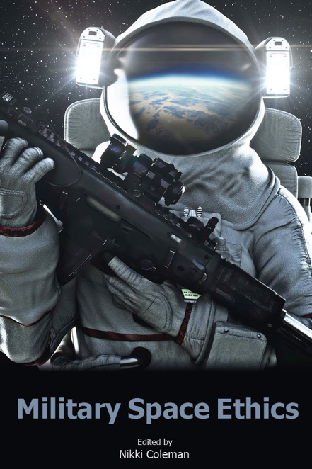
Military Space Ethics
Edited by Nikki Coleman

Military Space Ethics is a crucial and timely addition to the field of professional military ethics. It is incumbent on military professionals to ‘think forward’ concerning the ethical application of emerging technology, as well as the ethical use of force in this new domain. With contributions from leading scholars and practitioners from across the globe, Military Space Ethics will serve as a useful resource for military leaders, policy makers, and anyone interested in what the future of warfare may bring.
Dr Rebecca Johnson, Marine Corps University, Quantico

The space domain is undergoing disruptive changes to the technologies brought to bear on a rapidly growing range of challenges by a rapidly growing cast of actors. It is very reasonable to assert “not if but when” as we consider the possibilities. Unfortunately, as the opportunities mount so do the risks, including the risk of “contested, congested and competitive” turning into conflict. At such a time, it is crucial for ongoing safe and secure access to space-based services that we actively consider the underpinning ethics – should we engage in a particular activity, not just can we achieve it technologically or legally? These are questions for both the seasoned space-faring nations and ambitious and agile newcomers alike. The excellent collection of thinking and analysis provided in this new book could not be more timely.
Professor Russell Boyce FAIAA, Chair for Intelligence Space Systems, Director, UNSW Canberra Space
About the Book
As space develops as a potential war fighting domain, so does the need to have ethical scrutiny. Since the 1960s there have been core space treaties that together with national laws, provide a clear framework for both military and civilian space activities, yet ethical questions still exist around space warfare. Is it appropriate to respond kinetically on earth to a threat in space? Does just war theory apply in space and does the remoteness of space lower or raise the threshold for armed conflicts? Will the creation of new space forces start a space arms race? New combat environments also create a number of new challenges, including whether future war in space will be conducted by robots or space marines, and how the dual-use nature of satellites will impact on their permissibility as targets in any future conflict. As technologies become more widespread, space may be threatened by the likes of non-state groups and rogue states, leading to a need to inhibit their movement in space. In space, differences are magnified; resources are especially scarce, risks are multiplied, and specialized medical care is a world away. The physical and psychological distance between combatants in modern warfare applies also to space and the impacts of remote warfare need to be considered including the potential for moral injury and psychological trauma. With greater military power comes greater responsibility and this responsibility is carried out at the end of a chain of decisions and technologies. This book’s relevancy will not be lost on students at service academies and staff colleges in preparing them for the task of emphasizing ethical responsibility in space to those whom they will lead in the future.

Contents
Foreword – Chaplain Major General Steven A. Schaick; INTRODUCTION Revd. Dr Nikki Coleman; Introduction to Military Ethics in Space Dr Stephen Coleman; PART ONE – EARTH TO THE MOON; 1. Future War: Will it be Conducted by Robots or Space Marines? Lt. Gen. Christopher D. Miller; 2. Does Just War Theory Extend to the Space Frontier? Professor Patrick Lin; 3. In Space No One Can Hear the Geneva Convention: Jus in Bello and Warfare in Space Professor Pauline Shanks Kaurin; 4. What Is Needed to prevent Conflict in Space? Daniel Porras; 5. Space Debris: Can We Remove the Landmines of Earth Orbit Without Starting a War? Dr Stephen Coleman and Revd. Dr Nikki Coleman; 6. Ethical Considerations on the Challenges of the Dual-Use Satellite Problem Sergeant Amy Hestermann-Crane; 7. The Growing Threat of Terrorism in Space Revd. Dr Nikki Coleman and Dr Stephen Coleman; 8. The Problems Posed by Non-State Groups and Rogue States Exploiting Space Flying Officer Kaylee Verrier; 9. Bioethics and Military Operations in Space Assistant Professor Sheena M. Eagen; PART TWO – RETURN TO EARTH; 10. Star Laws: The Role of International Law in Regulating Civic and Military Space Activities Dr Cassandra Steer; 11. The Woomera Manual: Legitimising or Limiting Space Warfare? Dr Cassandra Steer; 12. Responding on Earth to Kinetic Attacks in Space Flight Lieutenant Geordie Jacobs; 13. Rocket Cargo: The Vanguard of the U.S. Space Force Nathan J. Philips (Navy Officer ret); 14. Where Space is Not an Option: African Ethics and the Options on Non-Contenders in Space Warfare Ibanga Ikpe; PART THREE – TO INFINITY AND BEYOND; 15. The United States Space Force and Space as a Military Domain Nathan J. Philips (Navy Officer ret); 16. From Peaceful Uses to Warfighting: The Dangers of the New Military Era in Space Dr Jessica West; 17. Post Traumatic Stress and Moral Injury in Extreme Remote Warfare Flying Officer Jayden Park; 18. What We Have is What We Bring There: Security in Space as Utopian Vision Dr Evie Kendal; 19. Vitoria the Universal Thinker: Some Ethical Dilemmas Concerning Space Exploration Francisco Lobo and Professor David Whetham; Index

Why should I read it?
Abraham Lincoln once said, “Determine that the thing can and shall be done, and then we shall find the way.” This book for many, will guide the journey. Steven A. Schaick, Chaplain, Maj. Gen. (Ret).

Publication date: 14th February 2022
Paperback 9781912440290
Price £29.99 / US$44.99 / €36.99 / Aus$59.99
Extent: 360 pages / Size: 234x156mm / Thickness 18.97mm / Weight: 1.115 lb

Issues in
Military
Ethics
Series

Co-Edited By
Don Carrick, King's College London,
Michael B. Skerker, United States Naval Academy
and David Whetham,
King's College London at the Joint Services Command and Staff College.

With most officer training schools including military ethics as part of their programme, more than ever there is a need for clarity on ethical decision making. Contemporary military conflict is ever changing and with it military practitioners are confronted by new ethical challenges which often put additional weight on the professional activity of personnel. At a minimum, military professionals need to have a clear knowledge of the laws that underpin their profession in order to evaluate situations quickly.

The series explores the complexities of acting ethically within the military system. It is not a philosophical debate on military ethics, nor is it a general introduction. Instead, this series aims to provide real world guidance for military commanders and leaders.

Areas of Interest

Cyber and Space

Professional Military Ethic

Emerging Ethical Challenges

Humanitarian Intervention

Law of Armed Conflict

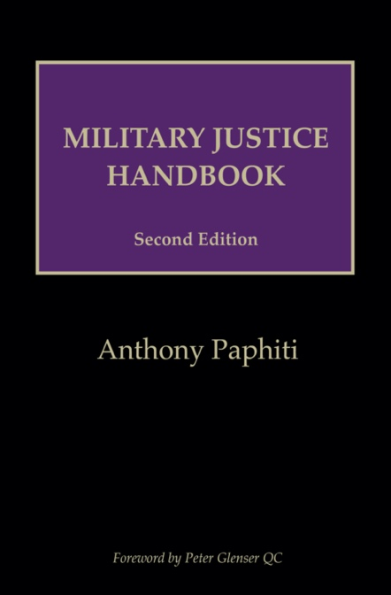
Military Justice Handbook
Second Edition
Anthony Paphiti

The Military Justice Handbook is THE essential text for anyone involved in the Service Justice System. I obtained my copy of the First Edition before my first ever military case and it has been my constant companion ever since. The Handbook serves as a primer for those new to the field and a reference point for seasoned practitioners. The Second Edition’s expanded content means no other book on the subject can match it for breadth and depth. It is simply the leader in the field and should be on the desk of every military law practitioner and commanding officer. Matthew Bolt,
Barrister, Middle Temple

The first edition of the Military Justice Handbook has deservedly become the practitioner’s de facto guide to UK Service law. The second edition stands on the shoulders of that giant. To many - if not most - practitioners, a veil of mystery shrouds much of military life. It need not be so. The Military Justice Handbook pierces the veil and provides a comprehensive summary of the law, complemented by the views of one of the most highly respected military lawyers of his generation. Of as much value to the seasoned military lawyer as it is to the aspirant, it would be foolhardy indeed for any lawyer or officer involved in the UK Service Justice System to be unfamiliar with the second edition. Wing Commander (Ret.) Allan R M.Steele WS RAF,
Principal Solicitor, ARMS Legal Services WS

As someone now merely an occasional practitioner within the Service Justice system I find this volume indispensable even though I spent thirty plus years as a practitioner within it. Excellent as a refresh or indeed first principal source for anyone embarking on trial by court martial as an advocate on whichever side. I have kept the first volume at my elbow and the same will apply to this one. Lucid, useful, and illuminating by turns it will be of particular use to the junior practitioner initially unaccustomed to the peculiarities of this trial arena. Brigadier (Ret.) Neil Jones LLB MA, Barrister,
New Park Court Chambers

★★★★★ This book sits by my desk and travels in my bag to court. Lewis Cherry, The Law Society Gazette
★★★★★…Anyone working for those in the military employment will find this to be a very clear and up-to-date guide…
Jeremy Taylor, The Law Society Gazette
About the Book
The second edition of the Military Justice Handbook represents a significant expansion on the first. Covering every aspect of the Service Justice System (SJS) in the United Kingdom, this book is designed as a ‘road map’ sufficiently detailed to qualify as a ‘go to’ guide, as the law and relevant policy of the SJS is complex and often difficult to find. Practitioners can now turn to the Handbook for guidance on any Service Justice topic. The book includes Summary Hearing, Administrative Action, as well as the Summary Appeal Court, and of course, the Court Martial, and an explanation of the appeal avenues open. The civilian and military legal practitioner (or indeed Service person) must understand this dynamic in order to fully appreciate how the system works holistically. Drafted with a non-legal audience in mind, no single publication brings together law, policy and (importantly) the nuances of the Service Justice System like this book. Readers are informed of the subsequent consequences on them or their client where they are subject to service discipline. Designed especially for military lawyers of all armed Services, civil servants working within the Service Justice System, commanding officers, unit discipline staffs and civilian legal practitioners advising Service personnel involved with Court Martial advocacy, Service Complaints, inquiries or administrative action.

Contents
Caselaw; Statutory References; List of Tables and Appendices; Foreword by Peter Glenser QC; Preface; List of Abbreviations; Introduction; Chapter 1 History: The Findlay Reforms; Chapter 2 Jurisdiction; Chapter 3 The Disciplinary System in Overview; Chapter 4 Chain of Command; Chapter 5 Arrest; Chapter 6 Investigation; Chapter 7 Commonly Used Service Offences; Chapter 8 Administrative Action By CO; Chapter 9 Summary Hearing; Chapter 10 Legal Aid; Chapter 11 Fitness To Stand Trial; Chapter 12 Pre-Court Martial Process; Chapter 13 Trial by Court Martial; Chapter 14 Sentences Available to the Court Martial; Chapter 15 Civilians in the Service Disciplinary System; Chapter 16 Appeals; Chapter 17 Young Offenders; Chapter 18 Victims of and Witnesses to Crime; Chapter 19 Other Important Provisions; Chapter 20 Service Inquiries and Coroners Inquests; Appendices; Index.

Why should I read it?
The MJH is focused on the practitioner with practical examples and case law. Court Martial practitioners, Commanding Officers and Discipline Staff, Officers and senior NCOs, comparative law scholars, civilian judges sitting in appellate jurisdiction and those interested in understanding UK Service law and its breadth will be helped by this book to navigate the complexities of Service law and procedure to better advise and represent clients.

Publication date: 26th March 2021
Paperback 978 1 912440 23 8
Price: £80.00 / US$120.00 / €100.00 / Aus$160.00
Extent: 820 pages / Size: 234x156mm / Thickness 41.326mm / Weight: 2.487 lb

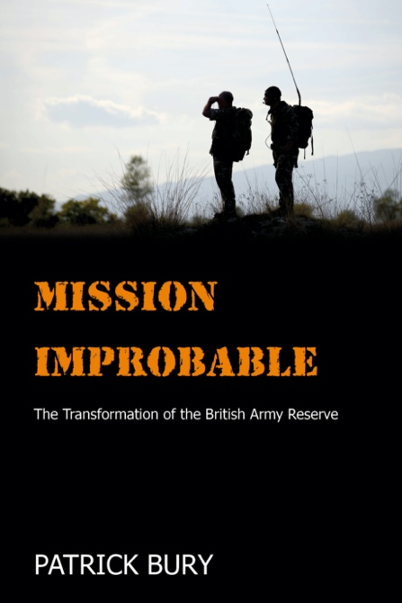
MISSION IMPROBABLE
The Transformation of the British Army Reserve
Patrick Bury, University of Bath, UK

Future attempts to transform the reserve have plenty to take from Bury’s study.
General Sir Peter Wall, GCB CBE DL

The book’s findings are both fascinating and also potentially incendiary.
Professor Anthony King

…this should be the ‘go to’ book for the latest thinking into one of the most marginalised, but highly politicised, populations – Reservists.
Professor Vincent Connelly

...thoroughly recommend this work especially to military scholars, military history 'buffs' and more especially politicians to understand the citizen soldier psyche.
The Australian Reservist

…an important contribution to the debate around wider Army Reserve and military logistics. This book should be read by anyone with more than a passing interest in the
reformation of the Reserves
The Wavell Room

About the Book
A central tenet of recent British defence policy, FR20 sought to radically transform the role and function of the British Army Reserve by making it more capable and more deployable, whilst simultaneously cutting costs by outsourcing logistics capability to reserve forces. In this book, Bury examines the origins, evolution and impact of the policy. He controversially shows how its intensely intra-party and intra-service political origins, the Army’s resistance to them, and the Army Reserves’ organisational nature, have undermined the policy’s ability to deliver the key military capabilities it envisaged. In doing so, he provides evidence of incoherent defence policy making in the Cameron era.

Contents
List of Figures; Acknowledgements; List of Abbreviations; 1 The Rise of the Reserves: The Post-Fordist Rise of the Reserves; Military Transformations; Professionalisation; Cohesion; Logistics Sub-units; The British Army Reserve; The Research; Overview. 2 Balancing Budgets, Strategy and Recruitment: Previous Reserve Transformations: The Cardwell-Childers Reforms: A First Attempt at Integration; Haldane and the Territorial Force; The First World War; The Second World War; Carver-Hackett Cuts Deep; Conclusion. 3 The Transformation of Military Logistics: Military Logistics; Post-Fordist Industrial Logistics; Adaption, Innovation, and the Legacy of Cold War Military Logistics; Centralisation; Integrating the Core and the Periphery; SCM and Outsourcing; The Emerging Logistics Network; Recent Tactical and Operational Logistics; Strategic Vulnerability? 4 ‘A Finger in the Wind Thing’: Intra-Party Politics and Origins of FR20: The Context of FR20; Background to FR20; Policy Exchange Paves the Way?; An Independent Reserves Commission?; Paired Fates: The Regular Army and Future Reserves 2020; Failure to Adapt: Organisational Reality Bites; The Politics of Numbers; Conclusion. 5 FR20: Delivering Capability?: FR20 Change Management; Main Effort: Recruitment; Equipment, Training and the Limits of Post-Fordism; Can These Sub-units Deliver? 6 FR20 and Cohesion: Standard Model Survey Results; A Different View of Cohesion; Logistics and Reserve Cohesion; The Persistence of Social Cohesion; The Decline of the ‘Drinking Club’; The Rise of Professionalism; Discipline; Conclusion. 7 FR20, Transformation and Society: An Emerging Division; SDSR 2015 and the Divisional Level as an Organisational Solution; FR20 as a Transformation?; FR20 and Civil–Military Relations; FR20 and Society; Bibliography; Index.

Why should I read it?
This is the most indepth analysis of the British Army reserves in over 25 years. Provides a key example of force transformation not seen since the abolition of conscription in 1960. Likely to become the standard ‘go to’ in a similar way that Walker’s book on the TA became in the 1990s. With controversial findings backed by extensive research, it’s a captivating read with some interesting and pertinent conclusions for the leadership of the British Army plus a number of lessons on how not to do transformation.

Publication date: 31st January 2019
Paperback 9781912440047 / Kindle 9781912440016 / EPUB 9781912440108
Price £29.99 / US$39.99 / €36.99 / Aus$59.99
Extent: 226 pages / Size: 234 x 156mm / Thickness: 21.01mm / Weight: 0.715 lbs

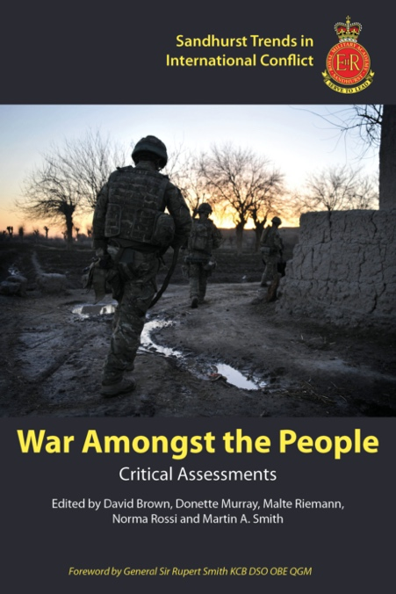
War Amongst the People
Critical Assessments
Edited by David Brown, Donette Murray, Malte Riemann, Norma Rossi and Martin A. Smith, Royal Military Academy Sandhurst

RMA Sandhurst has long played a key role in the intellectual development of
British Army and international officers. In this book, members of our
Academic Faculty bring together a distinguished team of scholars and military practitioners to tackle a key concept which challenges those, military and civilian,
who seek to better understand the evolving nature of contemporary conflict
and how - or indeed whether - external interventions can improve matters.

Major General PAE Nanson CBE
General Officer Commanding and Commandant Sandhurst

…Our Institutions, such as those of government and the armed forces, all developed in the context of Industrial War, the form of war that preceded wars amongst the people. The new circumstances require these institutions to change. In a volume such as this discomfort is good, as it generates debate and leads
to change.

General Sir Rupert Smith KCB DSO OBE QGM

About the Book
Recent conflicts have required the armed forces to engage in what has been termed ‘war amongst the people’. Such conflicts increasingly require a type of soldier deployed to function as an ‘armed social worker’, as was seen most recently in operations in Afghanistan and Iraq. If this increased focus on societal relations has – and should – become the area of prime concern for contemporary armed forces, this poses a series of conceptual and practical questions regarding the ‘people’ concerned and the nature of the society amongst which war is conducted. Scholars and practitioners come together in this volume to explore how armed forces can make sense of such complexity in conceptual terms and how military actors have practically interacted with local power structures and relations, with both positive and negative effects. It examines armed forces’ engagement at the local level in a contemporary context and contextualises this within the broader political, strategic, tactical and legal implications this engagement has had at home and overseas.

Contents
Foreword: General Sir Rupert Smith. Introduction: Dr Malte Riemann and Dr Norma Rossi. Part One: Conceptual Debates and Critiques Chapter 1: Prof Beatrice Heuser, Rethinking War; Chapter 2: Lt Col Jyri Raitasalo, The Utility - or Futility - of Force? What is Wrong with the ‘War Amongst the People’ Thesis?; Chapter 3: Dr Alex Waterman, Managing ‘War Amongst Peoples’. Part Two: Practical Challenges Chapter 4: Whitney Grespin, The Easy Button: Foreign Military Training as an Exit Plan; Chapter 5: Dr Vladimir Rauta, Conceptualising the Regular-Irregular Engagement: The Strategic Value of Proxies and Auxiliaries in ‘Wars amongst the People’; Chapter 6: Dr Georgina Holmes, Enhancing Operational Effectiveness: Pre-deployment Training for Tactical-level Rwandan Female Military Peacekeepers. Part Three: Legal Debates Chapter 7: Dr Andree-Anne Melancon, Redefining the ‘Combatant’: Just War Theory and ‘Direct Participation in Hostilities’; Chapter 8: Col Grant Davies, Revolving Doors and Human Rights: Detention in Internationalised Non-International Armed Conflict. Part Four: The UK Domestic Context of ‘War Amongst the People’ Chapter 9: Major Ian Wilson, UK Domestic Support for Wars: Polls and Public Opinion. Chapter 10: Major John Bailey, ‘War Amongst the People’: Responses in British Land Tactical Doctrine. Conclusion: Dr Norma Rossi and Dr Malte Riemann. Index.

Why should I read it?
This book is unique in the literature in that it brings together academics and service personnel to address this paradigm shift in war in a format that is accessible and relevant to military professionals. Authors are leading scholars in this field and military personnel include British infantry and Army Legal as well as a senior Finnish staff officer. Recommended reading by General Sir Rupert Smith author of ‘The Utility of Force’ in 2005 which first introduced the idea of ‘war amongst the people’, and Major General Paul Nanson, former Commandant of the Royal Military Academy Sandhurst.

Publication date: 10th May 2019
Paperback 978 1 912440 02 3 / Kindle 978 1 912440 03 0 / EPUB 978 1 912440 18 4
Price: £29.99 / US$44.99 / €36.99 / Aus$59.99
Extent: 290 pages / Size: 234x156mm / Thickness 15.34mm / Weight: 0.906 lbs
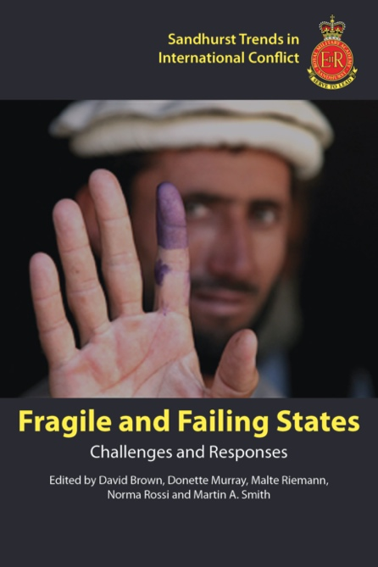
Fragile and Failing States
Challenges and Responses
Edited by David Brown, Donette Murray, Malte Riemann, Norma Rossi and Martin A. Smith, Royal Military Academy Sandhurst

This, the second book in our Sandhurst Trends series, makes a timely contribution not only to the ongoing academic and practitioner debates on state fragility and its consequences for the world, but also to advancing our core objective of securing the Academic Faculty at RMAS as an internationally recognised centre of excellence. In this book an international team of scholars and practitioners offer a diverse and challenging range of analyses on one of the most fundamental security and development issues of our time. I am especially proud that this initiative was successfully launched during my time as Commander RMAS and am looking forward to following its continued progress in years to come.

Brigadier WSC Wright OBE
Commander Sandhurst Group 2016-2019

About the Book
Since the early 1990s, the challenges posed by fragile and failing states have been a contentious and enduring part of the debates on post-Cold War international security. Though extensive, these debates have so far yielded little agreement on either the essential nature of state fragility and failure and what, if anything, potential outside intervenors can and should do to prevent it from developing, restore state functionality, or at least mitigate its impact and consequences. In this book, an international team of authors examine both the conceptual and practical challenges posed by this phenomenon. They consider the essential nature of the problem and through a variety of case studies, examine the effectiveness or otherwise of various regional and wider international responses in Africa, the Middle East and South America. This book will be of interest to both academics and practitioners engaged in studying and responding to the ongoing challenges posed by the existence of fragile and failing states in the contemporary international system.

Contents
Foreword: Colonel Richard Iron. Introduction: Dr Martin A. Smith. Part One: Conceptual Debates Chapter 1 Challenges to International Statebuilding: From Annihilation to Acceptance Prof David Chandler. Chapter 2 Building States to Build Peace Revisited: Empirical Insights from Peace Negotiations in Fragile States Jan Pospisil. Chapter 3 The Selective Nature of International Responses to Fragile, Failing and Failed States Dr Jacob Thomas-Llewellyn. Part Two: Challenges and Responses – Regional Case Studies Chapter 4 Somalia and its Neighbours: AMISOM and the Regional Construction of a Failed State Dr Jonathan Fisher. Chapter 5 The Rise of Strong Militaries in Africa: Defying the Odds? Lt. Col. Jahara Matisek. Chapter 6 Colombia and the Persistence of ‘Failed State Stigma’ in a Peace Scenario Prof Saúl M. Rodríguez and Prof Fabio Sánchez. Chapter 7 Foreign Intervention and the Process of State Failure: A Case Study of Libya 2011 Islam Goher. Chapter 8 Safe Havens: The Failed Strategy of the Failed State? Emily Knowles and Abigail Watson. Conclusion: Dr David Brown. Index

Why should I read it?
This book is unique in the literature in that it brings together academics and service personnel to address the topic of ‘fragile’, ‘failing’ and ‘failed’ states in a format that is accessible and relevant to military professionals. Authors are leading scholars in this field as well as a senior US Air Force staff officer. Recommended reading by Brigadier Bill Wright, Commander Sandhurst Group who also attended the event on which this book is based.

Publication date: 28th February 2020
Paperback 9781912440191
Price £29.99 / US$44.99 / €36.99 / Aus$59.99
Extent: 218 pages / Size: 234 x 156mm / Thickness: 11.684mm / Weight: 0.691 lb
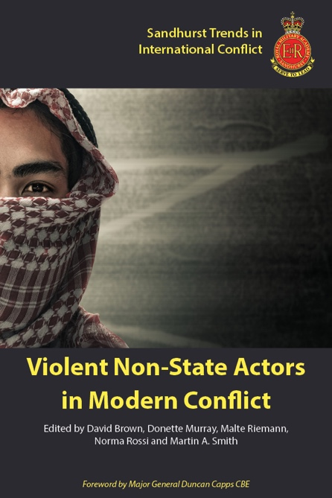
Violent Non-State Actors
in Modern Conflict
Edited by David Brown, Donette Murray, Malte Riemann, Norma Rossi and Martin A. Smith, Royal Military Academy Sandhurst

If you want to understand VNSAs theoretically, conceptually and empirically, this book is the one to read. The clarity of understanding around the core concepts of VNSAs (sovereignty, statism, legitimacy and de-legitimacy for example) makes this volume ideal for undergraduate studies, in particular, in the area of New Wars. Personally,
I see it as a core text on the topic.

Christopher Kinsey, King’s College London
at the Joint Services Command and Staff College

About the Book
Recent conflicts such as those in Syria, Libya, Iraq and Afghanistan are increasingly characterised by a pluralisation of irregular and privatised forms of violence. These actors include, among others, warlords, mercenaries, terrorists, transnational organised crime groups, foreign fighters and Private Military and Security Companies (PMSCs). While some pose a direct challenge to the state, others are in a complementary and symbiotic relationship with it. As such, violent non-state actors are both competing and cooperating with state actors in modern conflicts and their hybrid nature raises questions with regards to how best to understand these actors, as they often escape neatly defined categorisations. In modern conflicts the lines between terrorists and organised crime groups, irregular and regular forces, as well as economic and political motivations to fight, are increasingly blurred. As a result, ‘new’ and ‘old’ types of violent non-state actors are defining elements of modern conflict. The extreme complexity of twenty-first century conflicts requires a more integrated approach between military and civilian actors in order to respond more effectively to its challenges.

Contents
Foreword Major General Duncan Capps CBE. Introduction: Dramatis Personae Dr Donette Murray. Chapter 1 A Convergence of Territory: Warlords, Rebels and Terrorists in the Modern African State Dr Caroline Varin. Chapter 2 Who gets to fight? The De-Legitimation of Mercenaries and the Search for the Ideal Polity Helene Olsen. Chapter 3 Thinking Beyond the Divide: The Complex Relationships Between State/Non-state Armed Actors in Syria’s War Dr Helle Malmvig. Chapter 4 Violent Non-state Actors Write Their Own Laws of War Dr Jack Watling. Chapter 5 The Yemen Conflict at Sea: Houthi Maritime Operations and the Strategic Reconfiguration in the Gulf of Aden Dr James A. Fargher. Chapter 6 Warfare by Proxy: Russia’s Use of Violent Non-state Actors in Syria Dr Marina Miron. Chapter 7 Uneasy Alliances: The Political Consequences of Arming Non-state Groups in Counter-Terrorism Campaigns Abigail Watson. Chapter 8 The Evolving Character of Violent Non-State Actors in Modern Conflict: Perspectives from the Stabilisation Unit, Army Legal Services and the Land Warfare Centre Julien Bastrup-Birk, Lt Col Grant Davies and Lt Col Matthew Walker. Conclusion Dr Malte Riemann and Dr Norma Rossi. Index.

Why should I read it?
Uniquely bringing together academics and service personnel to answer your questions of how best to understand who are the violent non-state actors in today’s conflict, what are their potential threats and what this means for military strategy, approach, doctrine, structures and tactics going forward.

Publication date: 14th January 2021
Paperback 9781912440207
Price £39.99 / US$39.99 / €59.99 / Aus$79.99
Extent: 246 pages / Size: 234 x 156mm / Thickness: 12.21mm / Weight: 0.721 lbs

Sandhurst Trends
in International Conflict

Edited by

David Brown
Donette Murray
Malte Riemann
Norma Rossi
and Max Thompson

Royal Military Academy Sandhurst

The Royal Military Academy Sandhurst has been educating, training and inspiring members of the British Army since 1947. Internationally renowned for instilling the character and qualities necessary to provide leadership within an ever more complex security environment, the Sandhurst series blends academic and practitioner expertise to interrogate key trends and challenges impacting on contemporary conflict, its drivers, key features and responses at the international, regional, national and sub-national levels.

The Sandhurst series is a cutting-edge forum and platform for original thought and debate on military and security matters within the contemporary international security environment. It aims to stimulate authors to think critically about contemporary conflict and security more generally and to identify and interrogate practical, political and doctrinal lessons from recent experience. The Sandhurst series invites both practitioners – from the fields of security, diplomacy, the law, politics and the military - as well as both established and developing academics to participate and publish on the key debates that will shape both the contemporary international security environment and a modern military operating within it.

Areas of Interest

The contemporary battlefield/security environment

Strategy and doctrine

​ Military role within the wider security framework​

Efficacy of military force

The implications of contemporary military operations

Legality and ethics of military operations

Technology innovation and adaptation

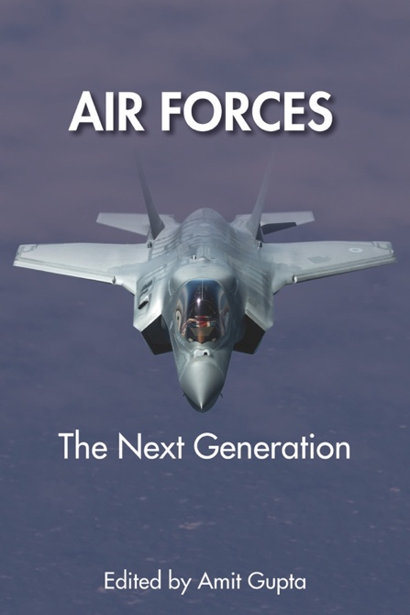
AIR FORCES
The Next Generation
Edited by Amit Gupta, US Army War College

Vital reading for Defense and National Security thinkers. Air Forces: The Next Generation lays bare the drivers of airpower development; a process where military capability and strategy often take a back seat to financial, cultural, and political realities. A careful read of this global airpower analysis brings home the complexity of modernization planning and the challenge of matching integrated technologies to required capabilities. Whether your interests focus on major international players or regional powers, this look at the airpower modernization will enhance your understanding of national decision making and the future of military force development.
Colonel Thomas McCarthy, PhD, Professor of Aerospace Studies (USAF)

This collection of contemporaneous views of 14 air forces from around the world explains not just the reasons for their development and structure but is forward leaning and identifies their future challenges and constraints. Each well-respected author highlights the uniqueness of the air force under consideration and as a whole, they find the thread that applies to all air forces, namely budgets and personnel. This book will make a valuable contribution to the professional library of air power scholars and enthusiasts.
Group Captain Andrew Gilbert, Director Air Power Development Centre (RAAF)

The challenge now for all air forces…is not so much to ‘do more with less’, but to ‘do better with what we have’. This book is replete with examples… Group Captain James R. Beldon MBE, Director of Defence Studies (RAF)

… a superb academic source. The Wavell Room
About the Book
The use of air power, like any other military force, is now becoming increasingly complicated. Missions are changing—an increase in intrastate wars, the use of air assets against terrorism and air forces deployed to conduct military operations other than war—coupled with budgetary and personnel pressures, continue to affect a nations ability to maintain competency in the aeronautical sphere of operations. Further, the number and type of actors deploying air power have changed, as has the technology. Each forward-thinking air force has now to consider potential threat scenarios that are futuristic and require some degree of planning. This volume contains data on 14 nations and their attempts to modernize, mobilize and keep ahead of their adversaries. Knowledge of other nations current force structure, doctrine and threat environment, how their budgetary pressures are affecting their acquisition decisions and whether they intend to seek interoperability provides assured and relevant information for your own aerospace capability program.

Contents
Notes on Contributors. Foreword Lt. Gen Steven L. Kwast, USAF. INTRODUCTION: Dr Amit Gupta, USAF Air War College. 1 AMERICA: Air Power Interventionism in a New Era Dr Ron Gurantz, USAF Air War College. 2 CHINA: The Quest for a Modern Air Force Professor Xiaoming Zhang, USAF Air War College. 3 RUSSIA: Modernizing Air and Space Capabilities Associate Professor Lars Peder Haga, Royal Norwegian Air Force Academy. 4 FRANCE: Light at the End of the Tunnel? Professor Guillaume de Syon, Albright College. 5 BRITAIN: The Thin Blue Line Professor Peter W. Gray (RAF Air Commodore 1* ret). 6 ITALY: At One Hundred, and Beyond Mr Gregory Alegi, Italian Air Force Academy and LUISS University. 7 GERMANY: The Future of the Luftwaffe Mr Richard Shimooka, Macdonald-Laurier Institute, Canada. 8 INDIA: Missions, Technologies, and Constraints Dr Amit Gupta. 9 AUSTRALIA: A Uniquely Strategic Environment WGCDR Pete Wooding (RAAF), Australian Command and Staff College. 10 PAKISTAN: Overcoming Strategic Constraints Dr Sharad Joshi, Middlebury Institute of International Studies, Monterey. 11 INDONESIA: Small Air Force, Big Nation Dr Adhi Priamarizki and Ms Tiola Javadi, Nanyang Technological University, Singapore. 12 TAIWAN: The Strait Challenge Dr Wu Shang-su, Nanyang Technological University, Singapore. 13 KENYA: Niche from the Start Dr Donovan C. Chau, University of West Florida. 14 BRAZIL: Control, Defend, Integrate Lt. Col. Luís E. P. Celles Cordeiro (BAF), Brazil Aeronautical Accidents Investigation and Prevention Center. CONCLUSION: Group Captain James R. Beldon MBE, Director of Defence Studies (RAF). Index.

Why should I read it? ‘The book’ focuses on the important facts and provides insight into today’s Air Forces by highlighting their political, budgetary, strategic and doctrine considerations. It is unique in the literature in that it brings together leading scholars and senior service personnel to address the topic of modernizing air forces and air power in a format that is accessible and relevant to military professionals. With the operational environment likely to become more complex, air forces must forward plan to deliver the next generation of air systems and a distinct advantage is in having a global understanding of the future battlespace for air power.

Publication date: 20th January 2020
Paperback 9781912440085 / Kindle 9781912440092 / EPUB 9781912440146
Price £29.99 / US$44.99 / €36.99 / Aus$59.99
Extent: 392 pages / Size: 234 x 156mm / Thickness: 20.48mm / Weight: 1.210 lbs
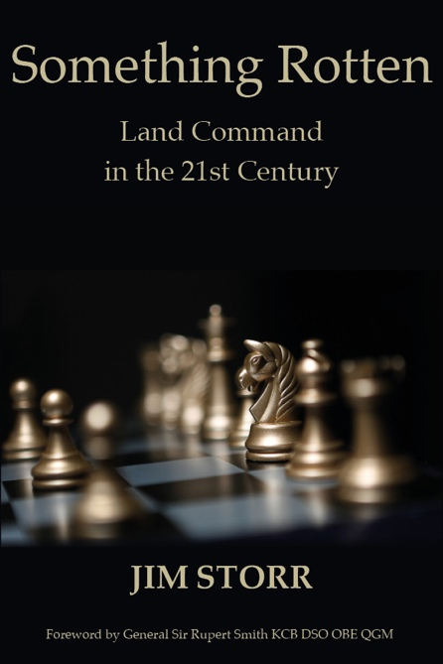
Something Rotten: Land Command in the 21st Century
Jim Storr

‘When the Gods of War come next to examine it, the Army’s obese and possibly sclerotic headquarters will be found wanting. It will be no good claiming that war and battle is complex. It was ever so ...’
General Sir Rupert Smith KCB DSO* OBE QGM

‘Jim Storr provides a crisp, informed, vigorous, and uncomfortable analysis of what has gone wrong with command systems in the British Army.’
Professor Sir Lawrence Freedman KCMG CBE

‘A scathing critique. Jim Storr is an original thinker who has never been afraid of asking the awkward question, never slow to challenge conventional wisdom, never shy of being deemed controversial or heretical. This book bears all those hallmarks. It is highly thought-provoking and stimulating.’
Lieutenant General Sir John Kiszely KCB MC

‘Jim Storr has produced a clarion call for action which I hope will be listened to by the British Army. Ignoring the issues raised will lead to failure, and the future British Army is too small to get a second chance.’
Lieutenant General Robert Baxter CBE

‘Jim Storr is Britain’s most lucid military thinker. In ‘Something Rotten’ he savages the zombified command practices and structures of Western armed forces. More, though, he provides a compelling way forward. This book is chock full of insight and good judgment. It is by far the most useful book on the subject since Martin Van Creveld’s Command in War.’
Professor David Betz, King’s College, London

'We started reading the book wanting to like it. We finished the book, loving it.... His insights into command must influence how we think....a must read for any serious officer or soldier.'
The Wavell Room

'This book is an important, convincing and compelling challenge to the status quo. Read it.'
★★★★★ The Army Rumour Service

About the Book
There seems to be something badly wrong with the command of western armed forces. Headquarters are too big. They produce orders which are too long. They take too long to do so. ‘Something Rotten’ looks at those problems by examining the command system as a whole. What is it for? What does it do? How does it do that? How is it structured and organised? Most importantly, what about the people who work in it?

Contents
Foreword; Acknowledgements; List of Accepted Meanings; Introduction; 1. Purpose; 2. Products; 3. Processes; 4. Structures; 5. Systems; 6. People; 7. Mission Command; Chapter 8. Observations and Conclusions; Index.

Why should I read it?
‘Something Rotten’ points out logical and practical problems with organisations and processes. It challenges the reader as to why such problems exist and persist. It suggests abandoning much overt process; building up human expertise; relying on fewer but better-trained people; and deciding and acting much faster.

‘Something Rotten’ focusses largely on the command of land forces. Other uniformed (and not necessarily armed) services will, however, readily identify parallels and insights.

Publication date: 9th May 2022
Paperback 9781912440269 Price £19.99 / US$29.95 / €25.99 / Aus$39.95
Hardback 9781912440405 Price: £59.95 / US$65.00 / €77.99 / Aus$65.00
Extent: 254 pages / Size: 234 x 156mm
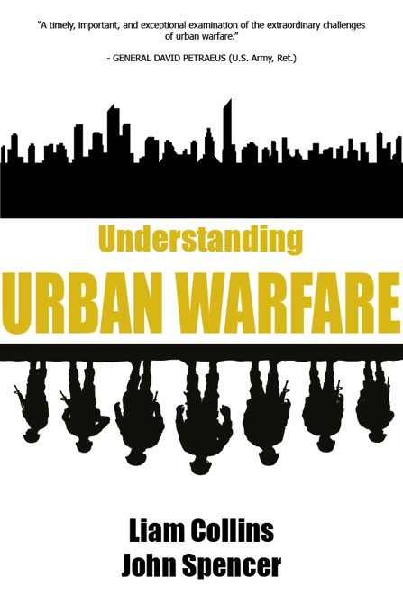
Understanding Urban Warfare
Liam Collins and John Spencer

As used by the United States Army. Amazon Bestseller.

“Understanding Urban Warfare’s ambitious title reflects the authors’ challenging objective to make combat’s most complicated form understandable - and Liam Collins and John Spencer have succeeded brilliantly. Leveraging the experiences of recent operations, they provide insights and lessons essential for soldiers and policymakers alike. A riveting read.” - General Stanley McChrystal (US Army, Ret.) former Commander of U.S. and International Security Assistance Force (ISAF) Afghanistan and the Joint Special Operations Command (JSOC), New York Times best-selling author of My Share of the Task and Team of Teams.
“A timely, important, and exceptional examination of the extraordinary challenges of urban warfare by two soldier-scholars with considerable experience and expertise in urban combat. Understanding Urban Warfare is the consummate study that demonstrates how critical it is that policy makers and military leaders understand the dynamics of urban ecosystems and how to deal with them.” - General David Petraeus, US Army (Ret.), former Commander of the Surge in Iraq, U.S. Central Command, and NATO and US Forces in Afghanistan, and former CIA Director.
“Impressive in both breadth and detail, Understanding Urban Warfare manages to be extremely readable and a very useful introduction to this vitally important subject.” - Sir Antony Beevor, author of Stalingrad, Berlin - The Downfall 1945, and D-Day - The Battle for Normandy.
"Our next war will most likely be fought in cities. Here Col Collins and Col. Spencer have compiled more than a dozen case studies, each featuring a different expert participant. The reader can grasp the challenge: It seems urban warfare, like all other branches of combat, is so sui generis that no cookie-cutter model of doctrine applies. So one has to read widely and adapt, adapt, adapt." - Bing West, bestselling author of No True Glory: A Front-line Account of the Battle for Fallujah.
“John Spencer and Liam Collins are to Urban Warfare what Billy Mitchel was to airpower or Karl Doenitz was to submarines.” - Max Brooks, New York Times best-selling author of World War Z and Devolution.
“Liam Collins and John Spencer have pulled together new insights and unique perspectives on Urban Warfare, a topic the importance of which is obvious after the renewed Russian invasion of Ukraine. Understanding Urban Warfare is a book that is a not only of immense value to military professionals, but also of interest to all who want to understand the character of todays and tomorrows armed conflicts.” - Lt. General H.R. McMaster (U.S. Army, ret.), the former National Security Advisor and bestselling author of Dereliction of Duty and Battlegrounds: The Fight to Defend the Free World.

About the Book
No environment is more challenging for militaries than a city. No form of combat is more inherently destructive than urban warfare. And yet too often, militaries are both unprepared for the challenges of cities and unable to avoid being pulled into brutal urban fights. In Understanding Urban Warfare, readers will gain more than just an appreciation of the unique challenges of urban warfare—from the limiting effects of three-dimensional terrain on many weapon systems and the multiplicity of enemy firing points on a city street to the overarching need to minimize civilian casualties and protect critical infrastructure and cultural property. The book also presents readers with new ways to understand the distinctive characteristics of a variety of cities—megacities, global cities, feral cities, and even smart cities—and how those characteristics impact military operations in urban terrain. Readers will also be provided first-hand accounts of some of the most relevant urban battles in modern history—the 1993 Battle of Mogadishu, the 2004 Second Battle of Fallujah in Iraq—plus the 2020 Battle of Shusha in the Second Nagorno-Karabakh War, and more—to illuminate trends and lessons to better understand urban warfare.

Contents
Introduction; Part I - Understanding the Operational Environment; 1. Understanding the City, John Spencer with Dr. David Kilcullen; 2. Feral Cities, John Spencer with Dr. Robert Norton; 3. Global Cities, John Spencer with Dr. Saskia Sassen; 4. Smart Cities, John Spencer with Dr. Sokwoo Rhee; 5. Megacities and the Military, John Spencer with Col. (ret.) Patrick Mahaney; 6. Beneath the City, John Spencer with Dr. Daphne Richemond-Barak; Part II - Operational Case Studies; 7. The Battle of Ortona, John Spencer with Major Jayson Geroux; 8. The Battle of Mogadishu, Liam Collins with Col. (ret.) Lee Van Ardsdale, Col. (ret.) Larry Perino, and Command Sergeant Major (ret.) Kyle Lamb; 9. The Second Battle of Fallujah, John Spencer with Lt. Gen. James Rainey; 10. Rebuilding Fallujah, John Spencer with Col. (ret.) Leonard DeFrancisci; 11. The Battle of Ramadi, John Spencer with Dr. Louis DiMarco; 12. The Battle of Sadr City, John Spencer with Lt. Col. (ret.) Rob MacMillan; 13. The Battle of Mosul, John Spencer with Maj. Gen. Roger Noble; 14. The Battle of Marawi, John Spencer with Dr. Charles Knight; 15. The Battle of Shusha; John Amble with John Spencer; Conclusion

Why should I read it? In an increasingly urban world, the future character of conflict will also be increasingly urban. This book sets out to understand that future.

Publication date: 3rd October 2022
Paperback 9781912440351 / Kindle 9781912440375 / EPUB 9781912440368 Price £19.99 / US$29.95 / €25.99 / Aus$39.95
Hardback 9781912440429 Price £59.99 / US$65.00 / €77.99 / Aus$65.00
Extent: 392 pages / Size: 234 x 156mm
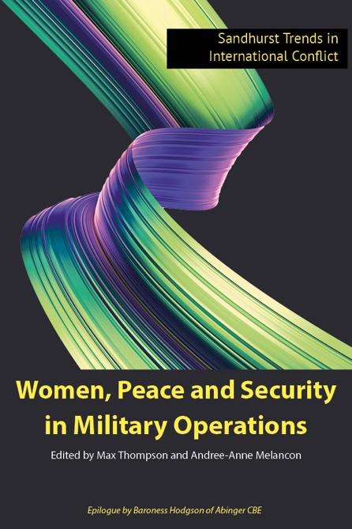
Women, Peace and Security in Military Operations
Max Thompson and Andree-Anne Melancon

'Recent history reminds us relentlessly that women, children and other vulnerable groups are often disproportionally affected by conflict and a lack of security. We must never lose sight of this harrowing truth, in our military planning and in our conduct and leadership in the battlespace. That is as true for air and space operators as it is for land forces, which is why this publication provides such an important reference for us all.'
Air Chief Marshal Sir Mike Wigston KCB CBE ADC, Chief of the Air Staff

'In an increasingly unpredictable world, in which civilian populations are too often impacted by conflict, it is hugely important that we focus on Women, Peace and Security. This focus enables Defence and the Royal Air Force to fully understand the context and challenges of conducting operations, so that our obligations can be better integrated at every stage of military planning and in the conduct of operations. As such, this publication provides an excellent and interesting contribution to international thinking, helping to improve our understanding of Security from diverse perspectives.'
Air Vice-Marshal Suraya Marshall CBE MA LLB RAF, Air Officer Commanding Number 2 Group, Royal Air Force

‘This book serves as a reminder of how far we have come, but also how much work is still to be done.’
Baroness Hodgson of Abinger CBE

‘This edited collection not only points out these challenges but offers substantive recommendations for military practitioners and policymakers. As such, it should be required reading for security professionals.’
Major General ZR Stenning OBE, Commandant Royal Military Academy Sandhurst

About the Book
Civilians are disproportionately impacted by contemporary armed conflict, with women, children, and other vulnerable groups among the most affected. Effective military operations occur against the backdrop of two major shifts in international thinking on security: Human Security and the Women, Peace and Security agenda (WPS). These innovations have radically transformed the field of contemporary security studies and continue to evolve and be debated in both academic and policy circles. However, militaries have been slow to adopt these ideas and adapt their behaviours to account for the importance of protecting civilians, gender mainstreaming, women’s participation, responsibilities on children in conflict, and preventing egregious crimes, such as modern slavery and human trafficking. This book is a conversation between academics and civilian and military practitioners to better understand the contemporary challenges and obligations militaries have towards realising the WPS agenda. Drawing on expertise from military, academia, and civil society it offers insights and recommendations on how militaries can effectively integrate the WPS agenda into their operations.

Contents
Foreword by Commandant Sandhurst, Major General Zac Stenning; Preface written by Dr Max Thompson and Dr Andree-Anne Melancon; Women, Peace and Security: What Happened in Afghanistan isn’t staying in Afghanistan Sanam Naraghi Anderlini; Chapter 1: Gender Mainstreaming in Peace Operations Dr An Jacobs and Dr Katerina Krusilova; Chapter 2: US Military Government, Civil Affairs, and WPS: Expanding Participation through Partnership Dr Spencer B. Meredith III; Chapter 3: Women, Peace and Security: UN Peacekeeping and the British Army Major Steven Maguire; Chapter 4: Hearts, Minds, Women, and Peace: US Militarized Human Security and Its Discontents Major Kelly Atkinson; Chapter 5: The Distinct Effects of Women Combatants on State- and Rebel-Perpetrated Rape Changwook Ju; Chapter 6: Enhancing Operational Effectiveness: Through an Analysis of the Women, Peace, and Security Environment in Djibouti Dr Whitney Grespin; Chapter 7: Making Sense of Armed Conflict: Gender Inequality and Climate Change in Operations Colonel (ret.) Jody M. Prescott and Dr Robin Lovell; Chapter 8: Bringing Women, Peace and Security Online: Applications in the Cyber Domain Dr Alexis Henshaw; Chapter 9: Educating Security: The Women, Peace and Security Agenda in Professional Military Education and Training Max Thompson and Andree-Anne Melancon; Epilogue The Baroness Hodgson of Abinger CBE; Appendix 1: National Gender Inequality Overlay Criteria Intervals; Appendix 2: Ex Complex Terrain; Annex: JSP985 - Human Security in Defence

Why should I read it?
This is a conversation between academics, civil society, and military practitioners to better understand the contemporary challenges and obligations militaries have towards realising the WPS agenda. Drawing on the expertise from these groups, it offers insights and recommendations on how militaries can effectively integrate the WPS agenda into their operations.

Publication date: 27th February 2023
Hardback 9781912440436 Price £59.95 / US$75.99/ €77.99 / Aus$75.99
Extent: 254 pages / Size: 234 x 156mm
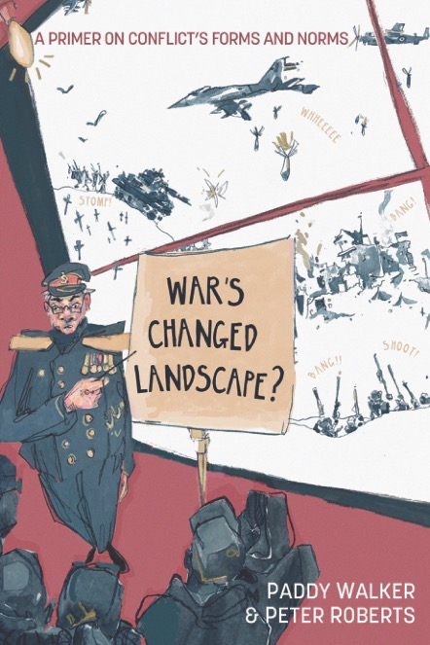
War’s Changed Landscape?
A primer on Conflict’s Forms and Norms
Paddy Walker and Peter Roberts

'…The authors rightly conclude that 'the conduct of war has changed very little regardless of one’s ‘timeline'. I cannot recommend this book strongly enough. Read it and re-learn some very old lessons!'
General The Lord Richards of Herstmonceux, GCB CBE DSO DL
Formerly Chief of the UK Defence Staff
''Context is everything' - the last words of this excellent book - capture how our ministers, officials and generals are a danger to us all if they stick with the certainties about war espoused so stridently over the last 30 years…’
General Sir Richard Lawson Barrons, KCB, CBE
Formerly Commander, Joint Forces Command
‘A refreshingly honest, brave, and insightful book drawing from thinkers at the top of their game. Challenging and prescient, War’s Changed Landscape demands to be read – and discussed.’ Professor Lloyd Clark, Director of Research, Centre for Army Leadership, RMAS
‘A clear-eyed unsentimental analysis that challenges many comfortable western assumptions about modern warfare. This book should be on the reading-list for every military planner and defence analyst.’
Rt Hon Sir David Lidington, KCB, formerly Chancellor of the Duchy of Lancaster and Minister for the Cabinet
Office, Chairman, Royal United Services Institute
'What are the enduring, the changing, and the novel features of warfare? This thoughtful study has as its forte its understanding of the impact of new technologies and resulting operational dimensions, war in its most concrete forms, a compass to war’s changed landscape for the practitioner.'
Professor Beatrice Heuser, Chair, International Relations, University of Glasgow
'In this timely primer, Walker and Roberts present a fascinating vision of changes in the relationship between international conflict practices, emerging military technologies, and the norms of war.'
Christian Enemark, Professor of International Relations, University of Southampton
'This is such an important read, and one I will go back to again and again as we seek to understand the constants, and accelerants of conflict in the Land Domain, and meet them.’
Major General Chris Barry, CBE, Director Land Warfare Centre, British Army
‘This book asks important, and sometimes inconvenient, questions about the future of war and warfare. A must-read for everybody who is interested in this topic.’
Professor Matthias Strohn, Director, Centre for Historical Analysis and Conflict Research, RMAS
About the Book
In late 2021, the new means of warfare were confidently being described by political and military leaders alike using phrases such as ‘grey zone’, ‘sub-liminal’ and ‘below the threshold of outright conflict’, a mix of hybrid strategies that would no longer involve the messy, noisy use of sticks and stones and bombs and gore. Future warfare was to be political warfare. Cyber and influence tools were the future and many academics agreed. In difficult retrospect, this was actually a narrative based on hubris and a simple extension of commentators’ own experiences over what had been twenty years of failed interventions.
But by February 2022, everyone had changed their tune. War was suddenly 20th century redux, a tapestry of trenches, bayonets and massed artillery that would have been quite familiar to participants of that century's two World Wars. The picture, of course, is more complicated and nuanced. Technology is disrupting practices and doing so right across battlespace. But hybrid warfare has very much not disappeared and political warfare in its many forms remains the overt strategy of several states notwithstanding unprecedented expansion in the means available to parties to undertake meddling and conflict.
It is quickly evident, moreover, that contemporary war is actually less defined by technical innovation than armchair experts would have you to believe. And disruptions today are too often tomorrow’s old news. Empirically, war’s norms and behaviours are quite slow to change with each shiny new driver for that change often giving rise to compelling versos and points of friction that combine to dull material transformation. This book unpicks the arguments made pre and post 2022 and, based on interviews with experts from around the world, seeks to dissect battlecraft’s enduring themes and how these may affect conflicts’ current norms.

Contents
Preface; Prologue; Introduction; Chapter 1: Context’s Continuum; Traditionalists, Pragmatists and Futurists; Chapter 2: Information and the New Importance of Data; Chapter 3: How Will Militaries Fight Wars? Realities, Ethics and Other Empirics; Chapter 4: How Will Conflict be Waged? The Dynamic of Conventional and Asymmetric Warfare; Chapter 5: Acquisition and Integration of Novel Systems into Legacy Force Design; Chapter 6: Autonomy and Thresholds of Supervision in Lethal Engagement; Chapter 7: Battlespace Fighting: Changes to Operations in Rear, Deep and Close Quarters; Chapter 8: Change Agents in Behavioural Norms; Conclusion; Bibliography; Executive Summary; Appendix: Participants.

Publication date: 13th November 2023 / Extent: 236 pages / Size: 234 x 156m
Paperback 9781912440498 Price £19.99 / US$29.95 / €25.99 / Aus$39.95
Hardback 9781912440481 Price £59.99 / US$65.00 / €77.99 / Aus$65.00
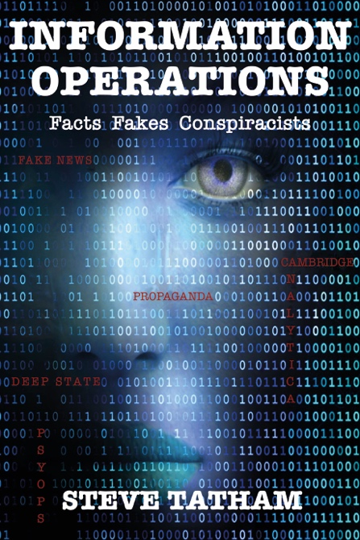
Forthcoming
Information Operations
Facts Fakes Conspiracists
Steve Tatham

‘This book captures how information shapes - even dictates - events and outcomes. The masters of managing the information that reaches us in all sorts of ways, and Steve Tatham is a master of over 25 years’ experience, take the rest of us where they want us to go, in peace and in war.’

General Sir Richard Barrons KCB CBE, Former Commander Joint Forces Command

‘For the first time one of the western world’s most experienced practitioners takes us inside the world of the ‘information operators’, practitioners of the most misunderstood and the most effective form of modern warfare, used by friend and enemy alike.’

Frank Ledwidge, Author Losing Small Wars

‘Steve Tatham is THE essential voice on info ops. Decades of experience make him the UK's most experienced practitioner and theorist. If you want to know about information operations read this book'

Dr Mike Martin, Author Why We Fight

About the Book
This book provides valuable insights into the world of information warfare, covering topics such as propaganda, disinformation, and psychological operations. With the rise of fake news and disinformation campaigns, this book is an invaluable resource for military personnel seeking to stay informed and vigilant. Whether you're a military professional, intelligence analyst, or simply interested in the topic, this book is essential for understanding the complexities of modern warfare and the impact of information operations. Written by a leading expert in the field, this book offers valuable insights into the tactics and strategies used by adversaries to manipulate public opinion and undermine national security. Stay ahead of the game and arm yourself with the knowledge contained in "Information Operations: Facts, Fakes, Conspiracists".

Contents
Preface; Introduction; Chapter 1: What are Information Operations?; Chapter 2: From Eunachs to the Archers: Britain and IO; Chapter 3: Bigger and Better?; Chapter 4: Iraq and Afghanistan; Chapter 5: Understanding Audiences; Chapter 6: Example of Past IO Campaigns; Chapter 7: Russia and Ukraine; Chapter 8: Iran, North Korea and China; Chapter 9: Its All About Psychology; Chapter 10: Conspiracy Theories and Useful Idiots; Chapter 11: The Cambridge Analytica Conspiracy; Chapter 12: Technology; Conclusion.

Why should I read it? This book is the culmination of Steve Tatham’s Information Operations career and is intended to be read by anyone, not least the men and women who today will be flung into vital IO assignments with little support. It is neither too academic nor too military and the various anecdotes and stories make it an enjoyable and accessible read.

Publication date: April 2024
Paperback 9781912440474 / Price £19.99 / US$29.95 / €25.99 / Aus$39.95
Hardback 9781912440467 Price £59.95 / US$65.00 / €77.99 / Aus$65.00
Extent: c.230 pages / Size: 234 x 156mm
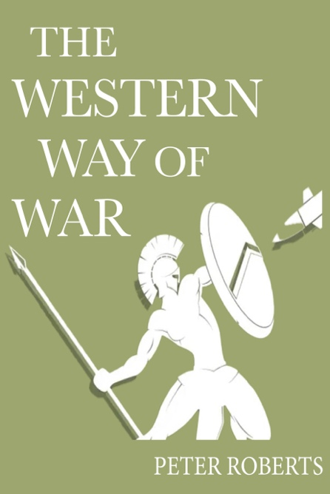
Forthcoming
The Western Way of War
Peter Roberts

About the Book
Peter Roberts has talked to many guests about the issues around ways of wars, how and why we fight, national security, and the Western approach to warfare. His audiences are in more than 180 countries around the world. To answer the call for a print version of his commentaries, this exciting volume contains interviews by esteemed politicians, retired Generals, and top professors. As we make the call on the final listing, rest assured this book will bring to you the many different perspectives on Peter’s burning question – What Does the Western Way of War Mean to You?

Publication date c. May 2024

Forthcoming
War and Warfare in the 20th Century
Jim Storr

About the Book
If you are a history enthusiast or a military buff, this book is a must-read for you. This guide offers a detailed analysis of major conflicts and military strategies throughout the century which has offered us the most (and the most relevant) material to examine. From World War I to the Gulf War, this book covers it all, offering a detailed examination of the pivotal moments and surprisingly novel perspectives in war and warfare. What did navies actually achieve? Did aircraft revolutionise warfare? How were the two World Wars actually won? Indeed what do winning and losing actually mean in relation to war? ‘War and Warfare in the 20th Century’ will make you think long and hard about what you thought you knew about war and warfare.

Publication date c. August 2024

Forthcoming
War Without Oversight
Why we need humans on the battlefield
Paddy Walker

About the Book
Autonomous Weapon Systems are robotic weapons that can sense and act unilaterally depending upon how they are programmed. They select targets and deliver lethality without human supervision. But material developments are required in hardware and software if this self-learning weapon category can legally be deployed on the battlefield. This book unpicks the manifest complexity involved in fielding a weapon that can operate without oversight while still retaining value as a battlefield asset. The subject's importance is that several well-tried concepts that have long comprised battlecraft may no longer be fit for purpose. The book dissects the highly coupled nature of routines that are envisaged for AWS operation in order to demonstrate why it will be enduringly problematic - and unwelcome - to remove humans from tomorrow's battlefields.

Publication date c. September 2024
Forthcoming
Conflict Realism
Understanding the Causal Logic of Modern War and Warfare
Amos Fox

About the Book
If you seek a compelling exploration of contemporary armed conflict, then this book is for you. It delves into the intricate web of causation to unveil five pivotal trends shaping the landscape of war and warfare - urban warfare, sieges, attrition, precision strike strategy, and proxy wars - revealing a stark reality: wars remain far more attritional than anticipated by policymakers, military practitioners, and analysts alike. What’s more, just as attritional wars are becoming quite common, conflict elongation – wars of extended duration – are also becoming the norm. Through insightful analysis and a keen understanding of geopolitical intricacies, Amos Fox navigates the reader through the intricate interplay of these trends, shedding light on their profound implications for global security. This riveting work challenges conventional wisdom, offering readers a thought-provoking perspective on the contemporary nature of armed conflicts, ultimately urging a reconsideration of strategies and policies in the face of an ever-evolving battlefield.

Publication date c. September 2024

Index

A
Adair, Professor John 3
Air Forces: The Next Generation 13
Alegi, Gregory 13
Allhoff, Fritz 4
Amble, John 15
Anderlini, Sanam Naraghi MBE 16
Atkinson, Major Kelly 16
Australian Reservist, The 8
B
Bailey, Major John 9
Baker (USN ret), Alan T. 3
Barnes, Colonel David M. 3
Barrett (Col USAF ret), Dr Edward T. 3, 4
Barrons KCB CBE, General Sir Richard 17, 18
Barry CBE, Major General Chris 17
Bastrup-Birk, Julien 11
Baxter CBE, Lt. General Robert 14
Beevor, Antony Sir 15
Beldon (RAF), Group Captain James R. 13
Betz, Professor David 14
Bolt, Matthew 7
Boyce, Professor Russell 5
Brigety, Ambassador Reuben E. 3
Brooks, Max 15
Brown, Dr David 9, 10, 11, 12
Bury, Dr Patrick 8
C
Capps CBE, Major General Duncan 11
Caroland, Captain James 4
Carrick, Don 3, 6
Celles Cordeiro (BAF), Lt Col Luís E. P. 13
Chandler, Professor David, 10
Chau, Dr Donovan 13
Clark, Professor Lloyd 17
Coleman RAAF, Reverend Dr Nikki 3, 5
Coleman, Lt Col Rafford M. 3
Coleman, Dr Stephen 3, 5
Collins, Colonel ret. Liam S. 15
Connelly, Professor Vincent 8
Cook, Colonel James 3
Cook, Professor Martin 3
Cooper (USMC ret), Lt. Col Scott 3
Cyber Warfare Ethics 4
D
Davies, Colonel Grant 9, 11
Davis, Dr Jeremy 4
DeFrancisci, Col ret. Leonard 15
DiMarco, Dr Louis 15
de Syon, Professor Guillaume 13
Deakin, Dr Stephen 3
E
Enemark Professor, Christian 17

F
Fargher, Dr James A. 11
Fishback (US Army ret), Ian 3
Fisher, Dr Jonathan 10
Flynn USN, CDR Michael A. 3
Fox, Amos 20
Fragile and Failing States 10
Freedman, Professor Sir Lawrence 14
G
Geroux, Major Jayson 15
Germano (USMC ret), Kate 3
Gilbert (RAAF), Group Captain Andrew 13
Glenser QC, Peter 4
Gray (RAF ret), Air Cdre Peter W. 13
Grespin, Whitney 9, 16
Goher, Islam 10
Goldwasser, LTJG Max 3
Good, LCdr Michael D. 3
Gross, Professor Michael L. 4
Gurantz, Dr Ron 13
Gupta, Professor Amit 13
H
Hestermann-Crane, Sergeant Amy 5
Henschke, Dr Adam 4
Henshaw, Dr Alexis 16
Heuser, Professor Beatrice 9, 17
Hodgson, Baroness of Abinger OBE 16
Holmes, Dr Georgina 9
I
Ikpe, Ibanga 5
Iron, Colonel Richard 10
Issues in Military Ethics series 3, 4, 5, 6
J
Jacob, Dr Carl 2
Jacobs, Dr An 16
Jacobs, Flight Lieutenant Geordie 5
Javadi, Tiola 13
Johnson, Dr Rebecca 5
Jones (ret), Brigadier Neil 7
Joshi, Dr Sharad 13
Journal of Military Ethics 3
Ju, Changwook 16
K
Kendal, Dr Evie 5
Kilcullen, Dr David 15
Kiszely KCB MC, Lt. General Sir John 14
King, Professor Anthony 8
King’s College London 3, 4, 6
Kinsey, Dr Christopher 11
Kleinman (USAF ret), Col Steven M. 3
Knight, Dr Charles 15
Knowles, Emily 10
Krulisova, Dr Katerina 16
Kwast (USAF), Lt Gen Steven L. 13
L
Lagacé-Roy, Professor Daniel 3
Lamb, Command Sergeant Major ret Kyle 15
Ledwidge, Frank 18
Lee, Dr Peter 3, 4
Lidington KCB, Rt Hon Sir David 17
Lin, Professor Patrick 5
Lobo, Francisco 5
Lovell, Dr Robin 16
Lucas, Professor George 4
Luna (SOC ret), Dan 3
M
MacMillan, Lt Col ret. Rob 15
Madison Policy Forum 15
Maguire, Major Steven 16
Mahaney, Col ret. Patrick 15
Malmvig, Dr Helle 11
Marshall CBE MA LLB, AVM Suraya 16
Martin, Dr Mike 18
Matisek, Lt Colonel Jahara 10
McCormack MBE, Reverend Professor Philip 3
McCarthy (USAF), Col Thomas 13
McChrystal, General Stanley (US Army Ret.) 15
McDermott, Lt Col Thomas 3
Melancon, Dr Andree-Anne 9, 16
Meredith III, Dr Spencer B. 16
Michel, Captain Mike 3
Military Justice handbook 7
Military Virtues 2
Milgrim, Jonathan 4
Miller, Lieutenant General Christopher D. 8
Miron, Dr Marina 11
Mission Improbable 5
Modern War Institute at West Point 15
Murray, Dr Donette 9, 10, 11, 12
N
Nanson CBE, Major General Paul A.E. 9
Nobel, Maj Gen Roger 15
Norton, Dr Robert 15
O
Olsen, Helene 11
Olsthoorn, Professor Peter 3
P
Park, Flying Officer Jayden 5
Paphiti (ret), Brigadier Anthony 7
Perino, Col ret, Larry 15
Philips, Nathan J. 5
Phillips, Erik 3
Peder Haga, Professor Lars 13
Petraeus, General David (US Army Ret.) 15
Porras, Daniel 5
Pospisil, Jan 10
Prescott, Colonel (Ret.) Jody M. 16
Priamarizki, Dr Adhi 13
R
Rainey, Lt. Gen James 15
Raitasalo, Lt Col Jyri 9, 7
Rauta, Dr Vladimir 9
Rhee, Dr Sokwoo 15
Richards GCB CBE DSO DL,General The Lord of Herstmonceux 17
Richemond-Barak, Dr Daphne 15
Riemann, Dr Malte 9, 10, 11, 12
Roberts, Professor Peter 17, 19
Robbins, Dr Scott 4
Robillard (Airborne Ranger ret), Dr Michael 3
Robinson, Professor Paul 3
Rodríguez, Professor Saúl M 10
Rossi, Dr Norma 9, 10, 11, 12
Royal Australian Air Force 5, 13
Royal (ret), Brigadier Benoit 3
Royal Military Academy Sandhurst (RMAS) 9, 10, 11, 12
Rubel (USN ret), Captain Rick 3
Ryan, Major General Mick 4
S
Sánchez, Professor Fabio 10
Sandhurst Trends in International Conflict series 9, 10, 11, 12, 16
Sassen, Dr Saskia 15
Sattler (USMC ret), Lt Gen John F. 3
Schaick, Chaplain Major General Steven A. 5
Schoonhoven, Professor Richard 4
Schwarz, Dr Elke 4
Shanks Kaurin, Professor Pauline 3
Shang-su, Dr Wu 13
Shimooka, Richard 13
Simpson, Professor Thomas W. 4
Skerker, Professor Michael 3, 4, 6
Smith, Dr David G. 3
Smith, Dr Martin A. 9, 10, 11
Smith KCB DSO OBE QGM, General Sir Rupert 9, 14
Spencer, Major ret. John 15
Steele (Wing Commander ret), Allan R.M. 7
Steer, Dr Cassandra 5
Stenning, Major General ZR. 16
Strohn, Professor Matthias 17
Storr, Jim 14
Stringer CBE RAF, AVM Johnny J. 3
T
Tatham, Commander Steve 18
The Wavell Room 3, 8, 13, 18
The Western Way of War 18
Thomas-Llewellyn, Dr Jacob 10
Thomas (RAF ret), Air Cdre John 3
Thompson, Max 16
Tidmash, Wing Commander Andrew M. 4
U
Understanding Urban Warfare 15
United States Military Academy at West Point 15
United States Naval Academy 3, 4, 6
V
Van Ardsdale, Col ret. Lee 15
Varin, Dr Caroline 11
Verrier, Flying Officer Kaylee 5
Violent Non-State Actors in Modern Conflict 11
Virgil, Colonel Scott M. 4
W
Wall GCB CBE DL, General Sir Peter 8
Walker, Lt Col Matthew 11
Walker, Dr Paddy 17, 19
War Amongst the People 9
War’s Changed Landscape 18
Waterman, Dr Alex 9
West, Bing 15
Watling, Dr Jack 11
Watson, Abigail 10, 11
Whetham, Professor David 3, 4, 5, 6
West, Dr Jessica 5
Wigston KCB CBE ADC, ACM Sir Mike 16
Wilson, Major Ian 9
Wolfendale, Professor Jessica 3
Wooding (RAAF), WGCDR Pete 13
Wright OBE, Brigadier Bill 3, 10
Z
Zhang, Professor Xiaoming 13

Sales and Distribution

PRINT
​
Worldwide
Ingram Content Group is a major distributor in the United States, distributing to almost 40,000 retailers, libraries, schools and universities. They facilitate customer orders of our books through bookstores and online retailers such as: Adlibris, ALS, Amazon, Barnes and Noble, Bertrams, Blackwell, Book Depository, Books Express, Foyles, Gardners, James Bennett, Paperback Shop, University Co-Operative Bookshop, Waterstones.
​
UK and Europe
Ingram Publisher Services UK (formerly NBN International) can process orders for UK and Europe direct.
IPSUK.Orders@ingramcontent.com (order processing)
IPSUK.customerservice@ingramcontent.com (customer services)
Telephone: +44(0)1752 202301
​
All print orders can alternatively be placed through our website: howgatepublishing.com

EBOOKS

Worldwide
Ingram Publisher Services provide eBook sales direct to customers.
​IPSUK.Orders@ingramcontent.com
​Telephone: +44(0)1752 202301
Nielsen PubEasy available for IPS UK trade customers
Amazon for Kindle
Ingram CoreSource distribution to more than 50 leading eBook partners

Registered Office

Howgate Publishing Limited
Station House
50 North Street
Hampshire PO9 1QU
UK
Email: info@howgatepublishing.com

As an environmentally conscious publisher, it is important to us that all of our suppliers adhere to high quality standards and have environmental certifications and initiatives from using sustainable paper to non-toxic inks. We always print locally.

Prices, publication dates and contents are subject to change without notice. Details of forthcoming titles are necessarily provisional. Up-to-date information is available on our website: howgatepublishing.com. We endeavour to despatch orders within 5 working days. In the event that a product is not available, orders will be recorded and the product despatched as soon as possible.

